Lab Report

Name: Tahsin Raihan Robbani
Id: 22201344
Course Title: Introduction to Biology
Course Code: BIO101
Section: 16
Faculty Name: Shabnam Ahsan (SHBM)

Blood grouping systems have been essential to medicine, especially for transplant and transfusion treatments. The ABO blood grouping system and the Rh system are two of the most important findings in this area. It is important to understand these systems in order to donate organs and perform safe blood transfusions.
According to Lederer (2013), In 1900 the Austrian immunologist Karl Landsteiner established that human blood was more than a simple biologically undifferentiated fluid. Through systematic mixing of the blood cells and sera of different individuals, Landsteiner discovered that human blood could be effectively divided into three distinctive groups based on the ways in which the cells reacted to the serum from other individuals. Landsteiner identified the presence of different blood types based on the reaction between red blood cells (RBCs) and antibodies. He classified human blood into four major groups: A, B, AB, and O. He also identified that the clumping occurred due to the presence of certain antigens on the surface of red blood cells (RBCs). Landsteiner's groundbreaking work earned him the Nobel Prize in Physiology or Medicine in 1930.
The method of classifying human blood based on inherited properties of red blood cells. The ABO blood group classification is based on the presence or absence of specific antigens (A and B) on the surface of RBCs and the presence of corresponding antibodies in the plasma. The A antigen, B antigen, both antigens (AB), or neither antigen (O) determines an individual's blood type.

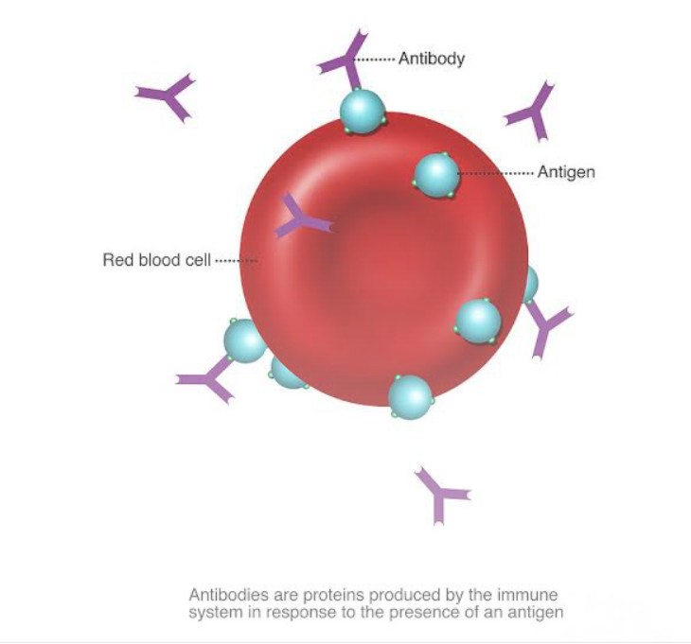

Figure: Red blood cell
- Blood Group A: Individuals with blood group A have the A antigen on their RBCs and produce antibodies against the B antigen.
- Blood Group B: Individuals with blood group B have the B antigen on their RBCs and produce antibodies against the A antigen.
- Blood Group AB: Individuals with blood group AB have both A and B antigens on their RBCs and do not produce antibodies against either antigen.
- Blood Group O: Individuals with blood group O lack both A and B antigens on their RBCs but produce antibodies against both A and B antigens.

The ABO blood group system is of immense significance in blood transfusion and organ transplantation. To avoid unfavorable reactions, the donor's and recipient's blood types must match. Understanding the compatibility of blood types is crucial to prevent adverse reactions during transfusions. The following principles govern blood transfusion compatibility:
- Type A blood can be transfused to individuals with blood groups A and AB.
- Type B blood can be transfused to individuals with blood groups B and AB.
- Type AB blood can be transfused to individuals with blood group AB.
- Type O blood, being the universal donor, can be transfused to individuals with any blood type (A, B, AB, or O).

Individuals with type O blood are universal donors, and individuals with type AB positive blood are universal recipients. The ABO system also plays a part in paternity testing, combability for organ transplantation and forensic investigations.

Another important system of blood typing is Rh system. Rh refers to the rhesus factor, an antigen found on the surface of RBCs. Individuals who possess the Rh antigen are Rh-positive, while those who lack it are Rh-negative. The Rh system is particularly important in pregnancy. If a Rh-negative mother carries a Rh-positive fetus, there is a risk of hemolytic disease of the newborn (HDN) in pregnancies. This occurs when the mother's immune system produces antibodies against the Rh-positive fetal blood, leading to severe anemia and other complications in the newborn. Rh compatibility is also crucial in blood transfusions to avoid Rh sensitization in recipients.

LAB: BLOOD TYPING (ABO SYSYEM)

List of materials:
- Microscopic slides
- Blood lancets
- Blood samples
- Blood grouping test kits
- Sterile toothpicks

Procedure:
- Divided a microscopic slide in three parts using a pen. Marked one part as A, second part as B and last part as D.
- Wiped one finger with alcohol saturated cotton and pricked with a sterile needle to draw blood.
- Put three drops of blood on the three separate parts of the slide.
- Put a drop of anti-A serum on part A, a drop of anti-B on part B and anti-D on part D.
- Mixed the serum and blood with toothpicks
- Then waited for the changes in A, B and D part.

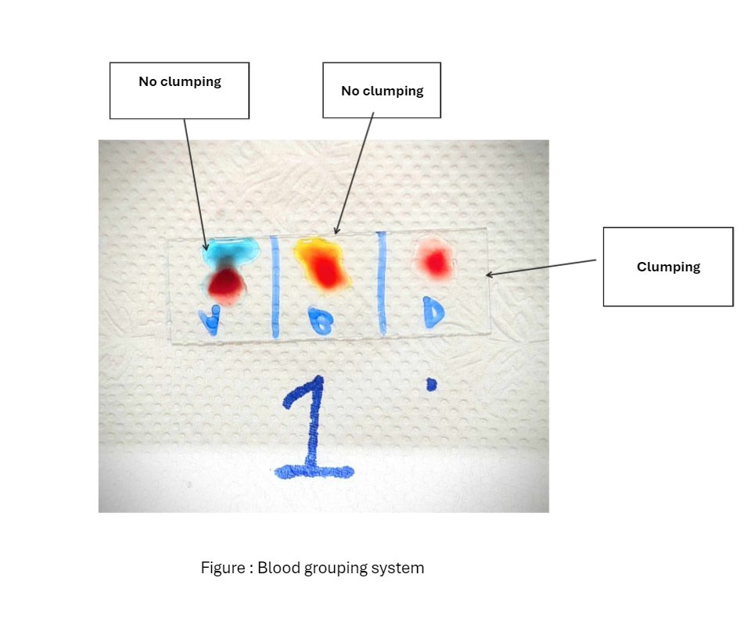
Observation & Results:
From the slides it is clear that there is no clumping of the blood sample with the anti A serum. Similarly, there is no clumping of the blood sample with the anti B serum. But in the part D which is for Rh serum I saw some blood clumping. After waiting a certain amount of time, I saw that it’s not fully clumped but it can a said it is a bit agglutinated. I think if I waited more, it would have been clearer and I would’ve get more precise information from the slide.

Discussion:
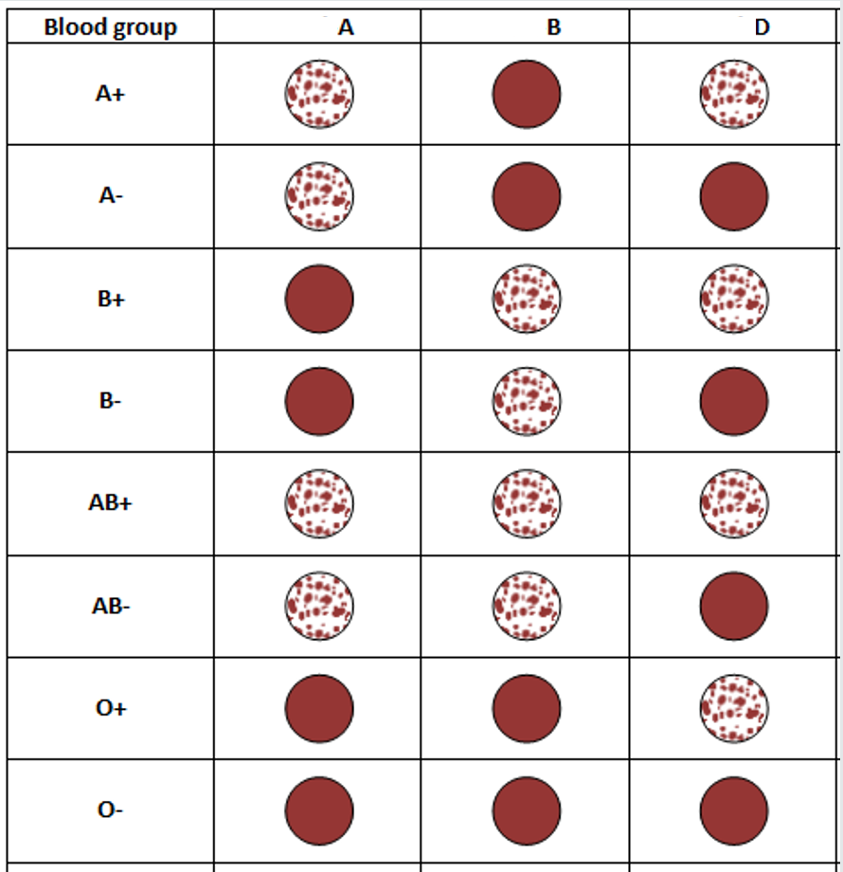
Figure: Blood grouping table

From the observation, ABO blood group result indicates that the sample does not possess either the A or B antigens. It indicates the absence of the A antigen and B antigen on the red blood cells but there is blood clumping in part D of slides. It indicates the presence of the Rh antigen on the red blood cells, resulting in a positive Rh factor. According to Offner. S (2015), individuals produce antibodies directed against antigen A or B. The only exception is that, since O antigen is really just a lack of A or B antigens, nobody makes O antibodies, so type O blood does not trigger an immune response in a person, regardless of their blood type. This is why the samples RBCs have the O antigen, which is considered the universal donor in the ABO system. This means that individuals with O positive blood type can donate blood to individuals with any other blood type within the ABO system (A, B, AB) without causing major adverse reactions. But individuals with the O blood type do produce antibodies to both A and B antigens, so they can’t receive these A, B or AB red blood cells. The O positive blood type individuals can only receive blood from compatible donors. They can receive blood from other O positive individuals or O negative individuals.
Reference

- BIO101 lab.pptx. (n.d.). Google Docs. https://docs.google.com/presentation/d/1w44BBcTd6wLkmkfBXAglwyTPqzAEUo0C/edit#slide=id.p4
- Lederer, S. E. (2013). Bloodlines: blood types, identity, and association in twentieth-century America. The Journal of the Royal Anthropological Institute, S118–S129. http://www.jstor.org/stable/42001732
- Offner, S. (2015). ABO Blood Groups. The American Biology Teacher, 77(8), 583–586. https://doi.org/10.1525/abt.2015.77.8.4

